**WEB DEVELOPER TASK**

**Mentor and Student Assigning with Database**

1. Write API to create Mentor:

http://127.0.0.1:3000/mentor

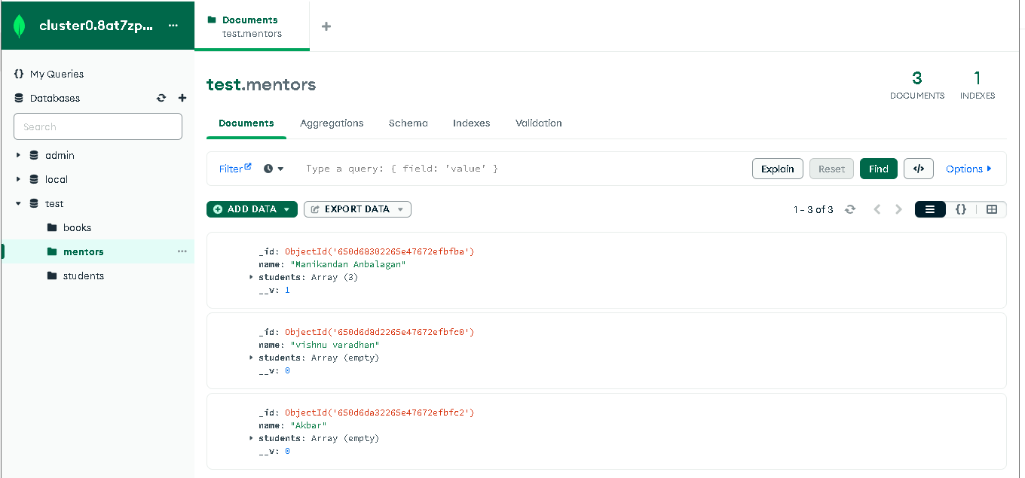

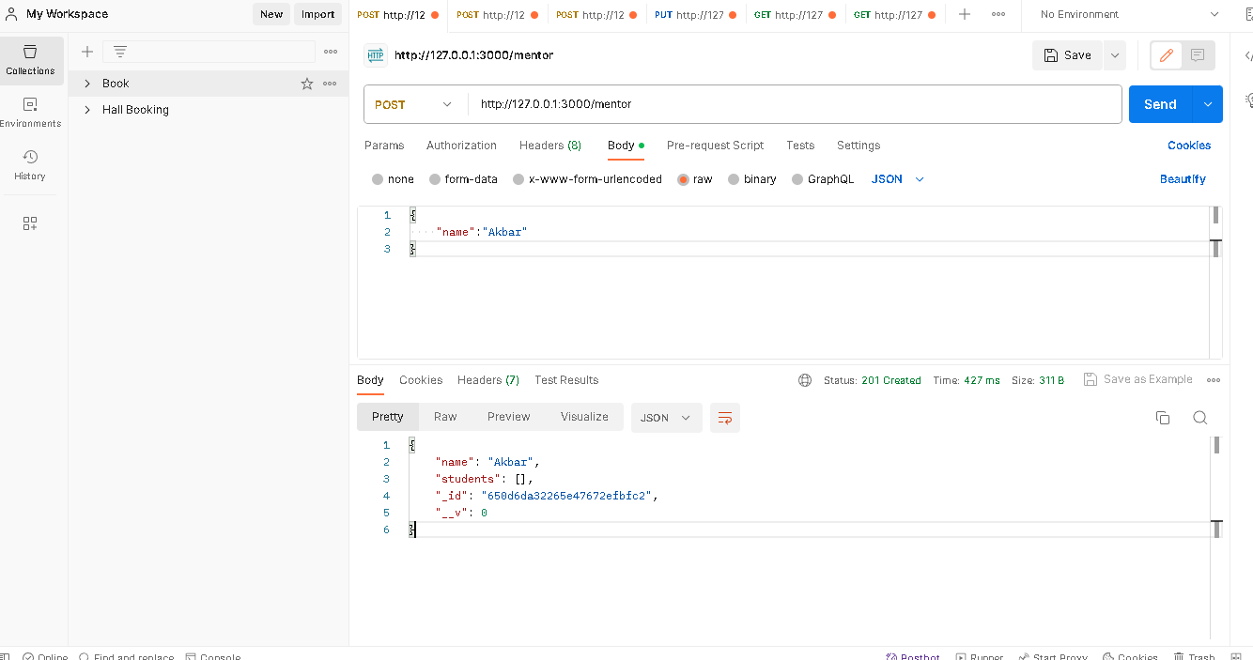

2. Write API to create Student:

http://127.0.0.1:3000/student

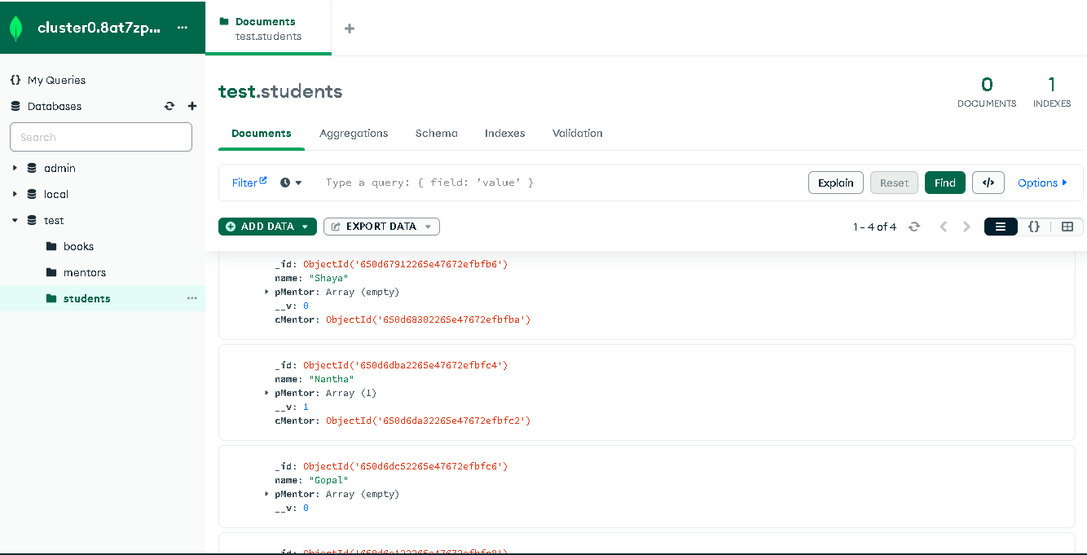

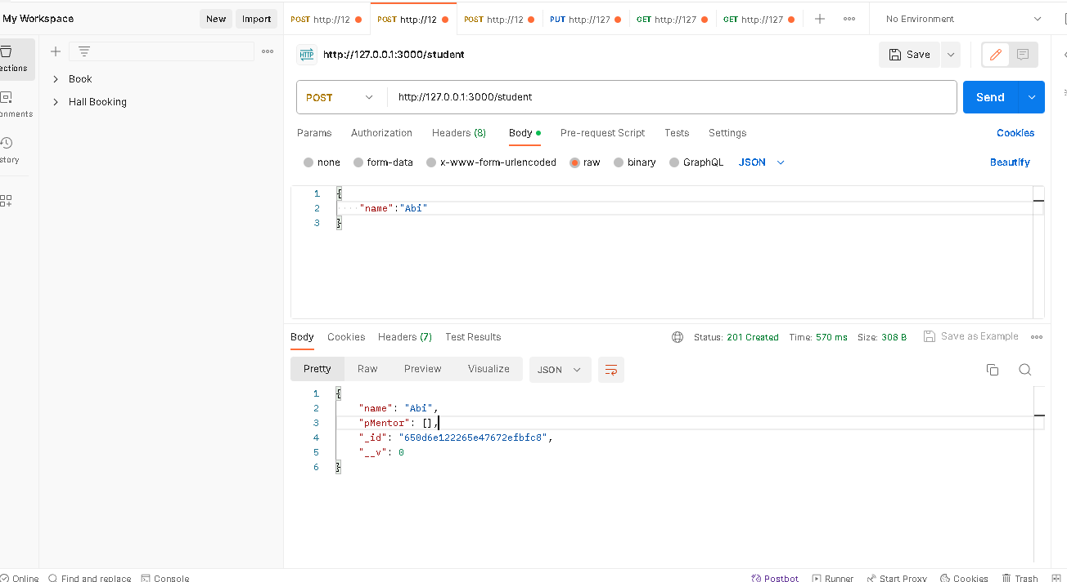

3. Write API to Assign a student to Mentor

* Select one mentor and Add multiple Student

http://127.0.0.1:3000/mentor/650d68302265e47672efbfba/assign

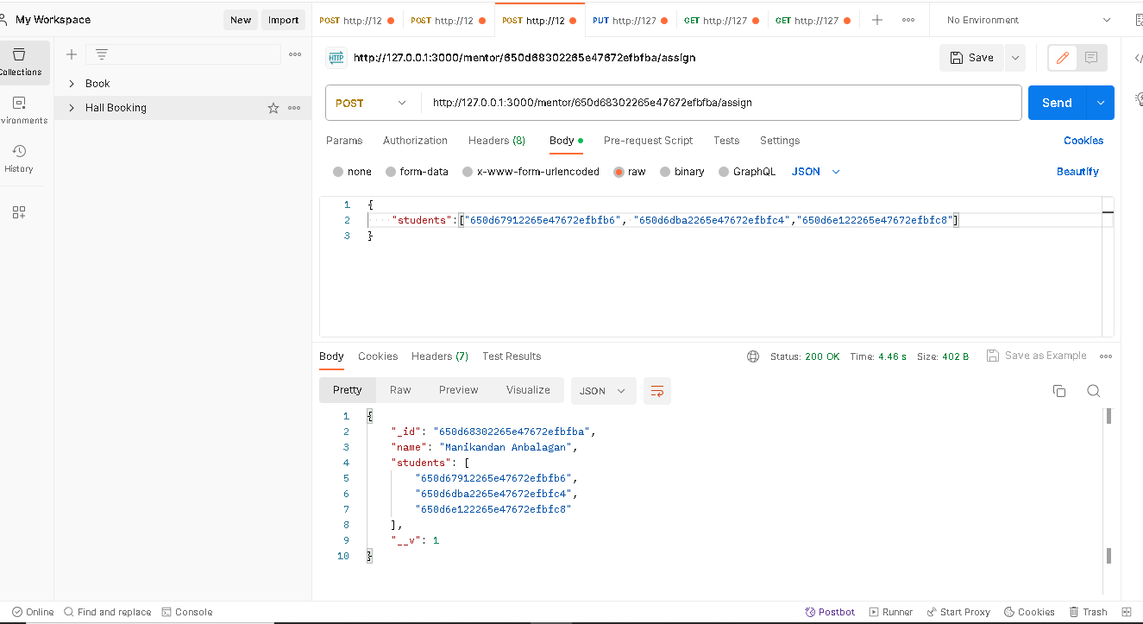

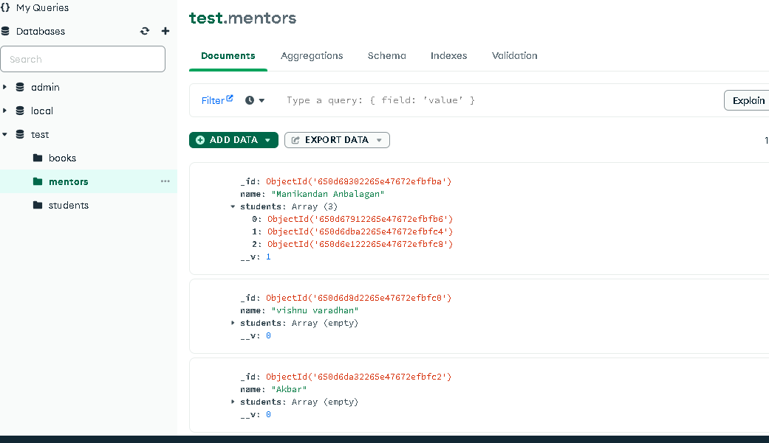

->A student who has a mentor should not be shown in List

http://127.0.0.1:3000/student/650d6dba2265e47672efbfc4/mentors

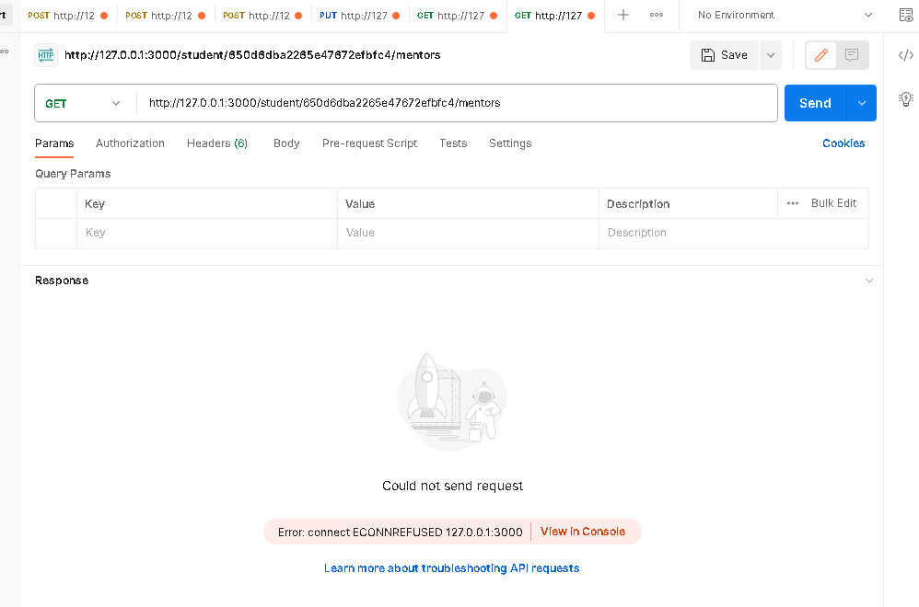

4. Write API to Assign or Change Mentor for particular Student

* Select One Student and Assign one Mentor

http://127.0.0.1:3000/student/650d6dba2265e47672efbfc4/assignMentor/650d6da32265e47672efbfc2

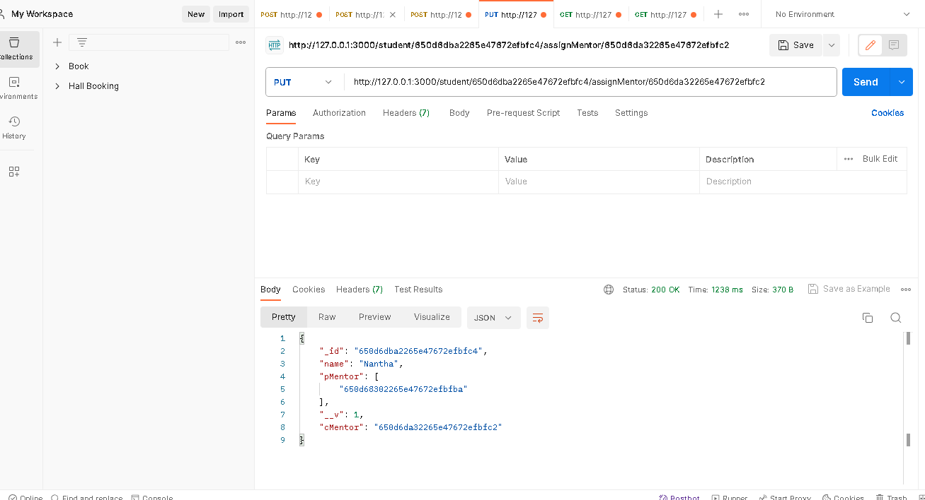

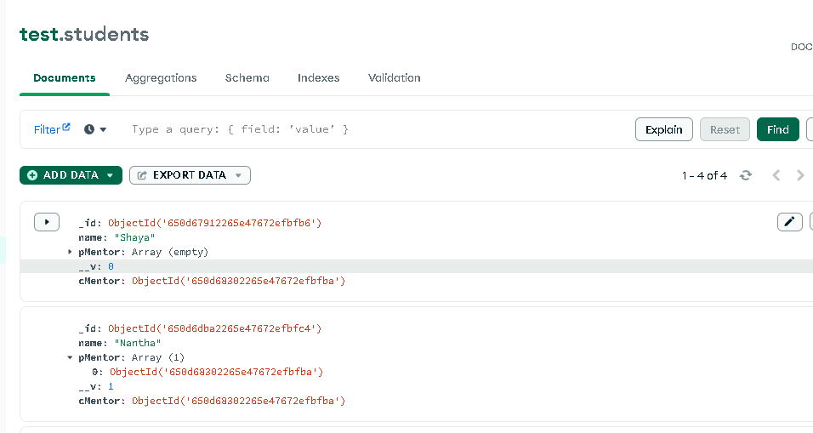

5.Write API to show all students for a particular mentor

<http://127.0.0.1:3000/mentor/650d68302265e47672efbfba/students>

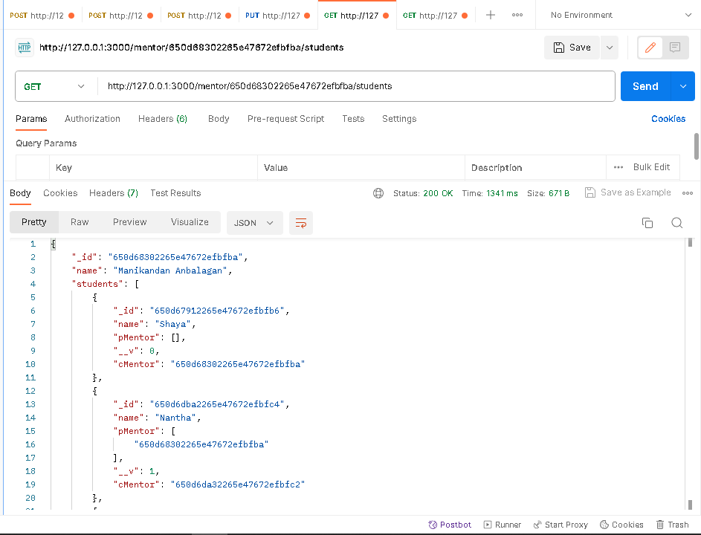

6. Write an API to show the previously assigned mentor for a particular student.

http://127.0.0.1:3000/student/650d6dba2265e47672efbfc4/assignMentor/650d6da32265e47672efbfc2

